= Task1

(1 – vreg, 2 – vpwm, wavegen - vctrl)

|  |  |  |  |  |
| --- | --- | --- | --- | --- |
| vctrl | duty | vpwm | vreg | supply (v) |
| 0.36 | 10.756 | 2.5038 | 3.0991 | 5 |

3: relationship between v_ctrl, duty cycle of v_pwm, and v_reg

4v

|  |  |  |  |
| --- | --- | --- | --- |
| vctrl | duty | vpwm | vreg |
| 3.5 | 77.338 | 4.0652 | 1.1425 |
| 3 | 67.6 | 4.0725 | 1.3225 |
| 2.5 | 57.87 | 4.0431 | 1.6679 |
| 2 | 47.548 | 4.0505 | 2.1124 |
| 1.5 | 36.376 | 4.0468 | 2.5937 |
| 1 | 24.603 | 4.0137 | 3.1191 |
| 0.5 | 15.549 | 3.279 | 3.7254 |
| 4 | 91.36 | 4.0321 | 0.74565 |
| 4.5 | 100 | 4.0101 | 0.010823 |
| 5 | 100 | 4.055 | 0.010823 |
| 0 | 2.6541 | 2.3348 | 3.9679 |

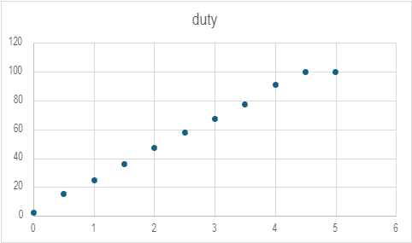

5v

|  |  |  |  |
| --- | --- | --- | --- |
| vctrl | duty | vpwm | vreg |
| 2.5 | 48.706 | 5.0705 | 2.8379 |
| 2 | 39.971 | 5.0742 | 3.3396 |
| 1.5 | 30.584 | 5.0185 | 3.3396 |
| 1 | 20.823 | 5.0154 | 3.3396 |
| 0.5 | 12.059 | 3.9574 | 3.3396 |
| 0 | 4.5602 | 3.2006 | 3.3396 |
| 3 | 56.896 | 5.0558 | 2.3943 |
| 4 | 72.176 | 5.0824 | 1.8073 |
| 3.5 | 64.681 | 5.0604 | 1.9575 |
| 5 | 91.95 | 5.0314 | 1.0237 |
| 4.5 | 79.998 | 5.0791 | 1.5953 |

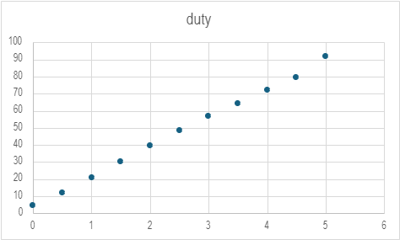

[911.xlsx](https://purdue0-my.sharepoint.com/:x:/r/personal/dradzely_purdue_edu/Documents/911.xlsx?d=w75f3c100cd264a0a9c524bc043a4be21&csf=1&web=1&e=7obUio&nav=MTVfe0Y5RTI0MkUwLTgzMTQtNDZEOS04Qzk5LUIxN0REM0RGQ0IzRH0)

|  |  |  |
| --- | --- | --- |
| vCTRL | vPWM duty cycle | vREG |
|  |  |  |
|  |  |  |
|  |  |  |
|  |  |  |
|  |  |  |
|  |  |  |
|  |  |  |

4: v_ctrl / duty cycle for 2.5V output

5. v_ctrl and pwm with 4v supply when v_reg = 2.5V

Task2

1: R_1 and R_2 values (both 22 kOhm) (v_err = v_ref – v_reg + v_off):

(1 - vERR)

4:

Supply: 5v

|  |  |
| --- | --- |
| V_reg (swept from 1-4 v) | V_err |
| 1 | 3.62 |
| 1.5 | 3.46 |
| 2 | 2.96 |
| 2.5 | 2.46 |
| 3 | 1.96 |
| 3.5 | 1.45 |
| 4 | .95 |

5:

Supply: 4v

|  |  |
| --- | --- |
| V_reg (swept from 1-4 v) | V_err |
| 1 | 2.64 |
| 1.5 | 2.65 |
| 2 | 2.5 |
| 2.5 | 1.99 |
| 3 | 1.49 |
| 3.5 | .99 |
| 4 | .6 |

6: What is the output voltage when the error is zero for each case:

Task3

2: Average value of v_ctrl and v_reg when supply voltage is 5

channel 1 – vREG, channel 2 - vCTRL

V_ctrl: 3.69 V

VREG: 4.91 V

3: sweep supply from 4-5 and measure v_Ctrl at each step

|  |  |
| --- | --- |
| V_supply (vcc) 4-5 | V_ctrl (V) |
| 4 | 2.699 |
| 4.1 | 2.79 |
| 4.2 | 2.89 |
| 4.3 | 2.99 |
| 4.4 | 3.09 |
| 4.5 | 3.19 |
| 4.6 | 3.29 |
| 4.7 | 3.39 |
| 4.8 | 3.49 |
| 4.9 | 3.59 |
| 5 | 3.69 |

4. oscilloscope screenshot of power up sequence (turn off supply, set oscilloscope to single trigger, turn on supply) (channel 1 – vREG, channel 2 - vCTRL)

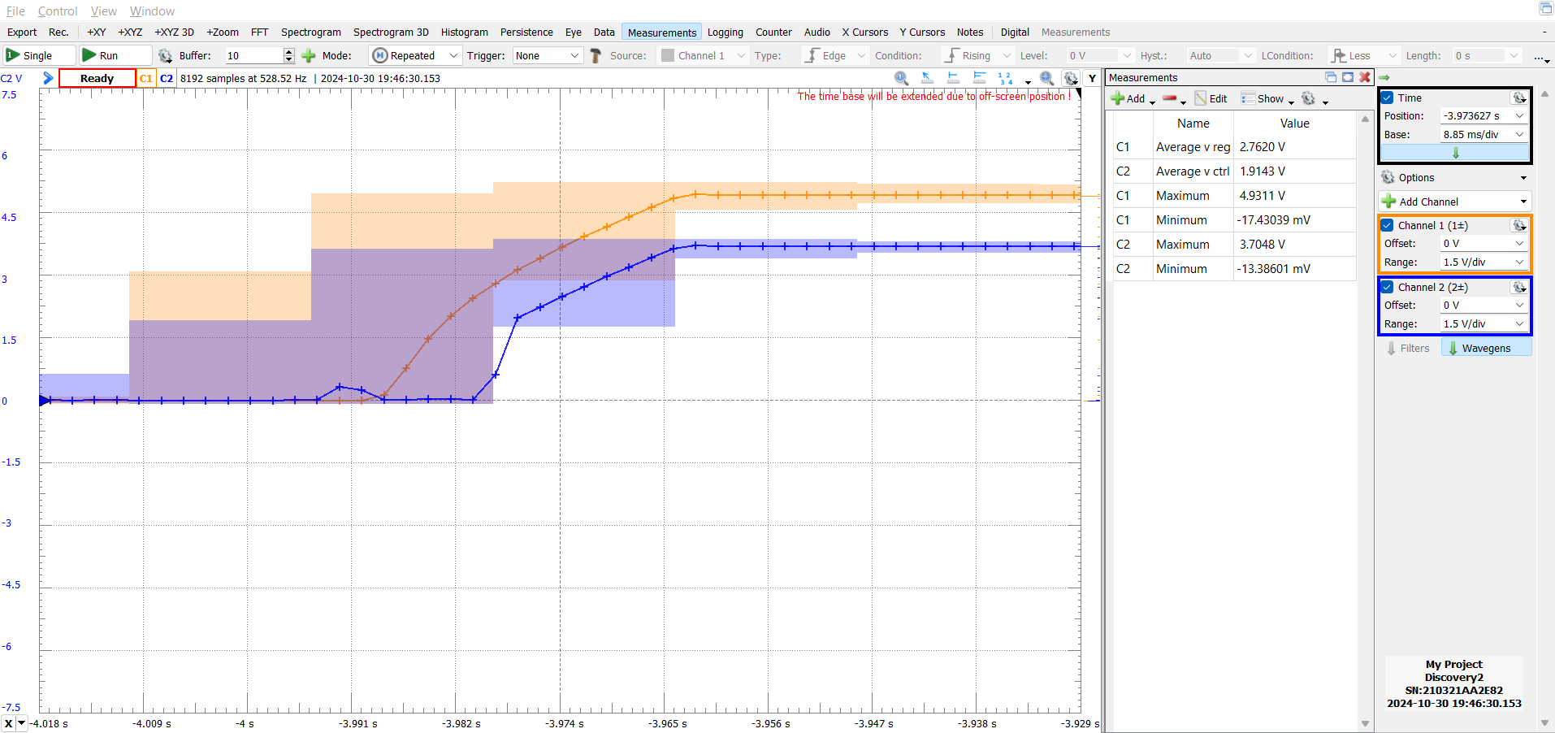 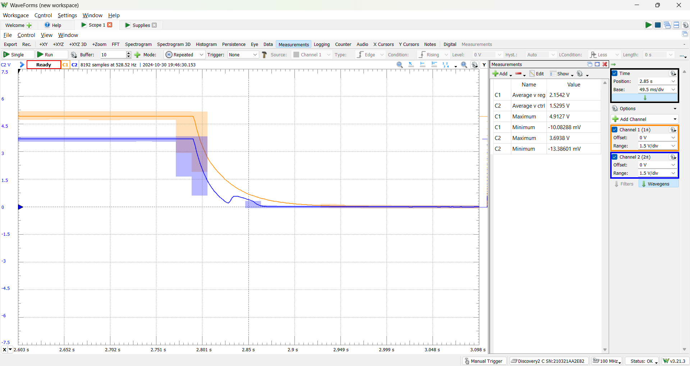

5: rl = 150 ohm, what is v_reg and v_ctrl

V_ctrl: 3.65 V

VREG: 4.83 V

6: relationship between supply and control voltage, relationship between rl and control voltage

7: replace 33k with 2.2k and measure v_ctrl and v_reg

V_ctrl: 3.66 V

VREG: 4.85 V

* Oscilloscope screenshot of v_ctrl and v_reg

